TECHNICAL PROJECT REPORT

# Title of Invention / Project:

# **Voice Control Pet**

# Team Members / Inventors:

|  |  |  |  |  |  |
| --- | --- | --- | --- | --- | --- |
| **S. No.** | **Name** | **Department** | **Designation** | **Mobile** | **E-Mail** |
| 1. | R Dinesh Sai | ECE | STUDENT | 9490851597 | rallapallidineshsai33@outlook.com |
| 2. | Sarthak | ECE | STUDENT | 9467485265 | sarthakchoudhary99@gmail.com |
| 3. | Arjun | ECE | STUDENT | 7006344472 | gupta.arjun94199@gmail.com |
| 4. |  |  |  |  |  |
| 5. | Khushal Thakur | ECE | Mentor | 9646030764 | khushal.thakur@cumail.in |
| 6. | Anshul Sharma | ECE | Mentor | 9478697475 | anshulsharma.ece@cumail.in |
| 7. | Kiran Jot Singh | ECE | Mentor | 9463909689 | kiranjotsingh.ece@cumal.in |
| 8. | Divneet Singh Kapoor | ECE | Mentor | 9878422653 | divneet.ece@cumail.in |

Section – 1 (IPR Related)

# Brief Abstract (500 words):

* **Problem faced and how solved it.**
* The main aim to is to make a model of voice control pet. When the making process was going some problems had been occurred. When troubleshooting was done. Problems were identified, the recognised mistake was that my body structure was facing some problems when it is turning left and right. Again The body was re-built When the code was verified some loop holes are found. Again the code was modified. Now the model is working in a perfect manner.
* **Additional modifications that can be added to model.**
* The additional specifications that can be add to model are:

1. A ultrasonic sensor for obstacle detection.
2. A camera can be added for capturing pictures.
3. The model can be modified from voice control to gesture control.
4. A LCD can be added to display pictures.

# Existing state-of-the-art and Drawbacks in existing state-of-the-art

|  |  |  |
| --- | --- | --- |
| **S. No.** | **Existing state of art** | **Drawbacks in existing state of art** |
| 1 | https://www.youtube.com/watch?v=fNFVHupdBic&t=1s | Its getting stressed to recognize the sound. |
| 2 |  |  |

# Novel/Additional modifications that you can propose to improve upon drawbacks

* The additional feature that can be added to project model is fixing a camera.
* The additional feature that can be added to project model is fixing a ultrasonic sensor.

# Advantages

* For capturing the images.
* To detect obstacles.

# Block Diagram

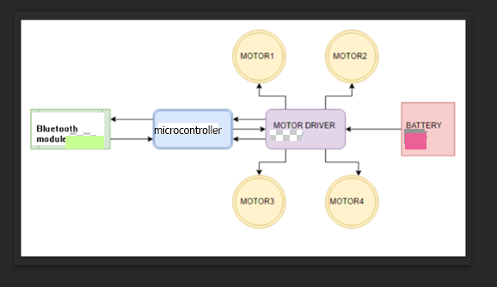

Section – 2 (Real Project)

# Materials

|  |  |
| --- | --- |
| **Materials** | **Price** |
| * Arduino UNO(Microcontroller) * L298N Motor Driver | Rs.500  Rs.200 |
| * Bluetooth Module HC-05 | Rs.250 |
| * 4 motors with wheels | Rs.600 |
| * Three wood pieces for body | Rs.150 |
| * Wires and Jumper wires | Rs.70 |
| * 9 V cell | Rs.20 |
| * 12 V cell | Rs.300 |

# Circuit Diagram

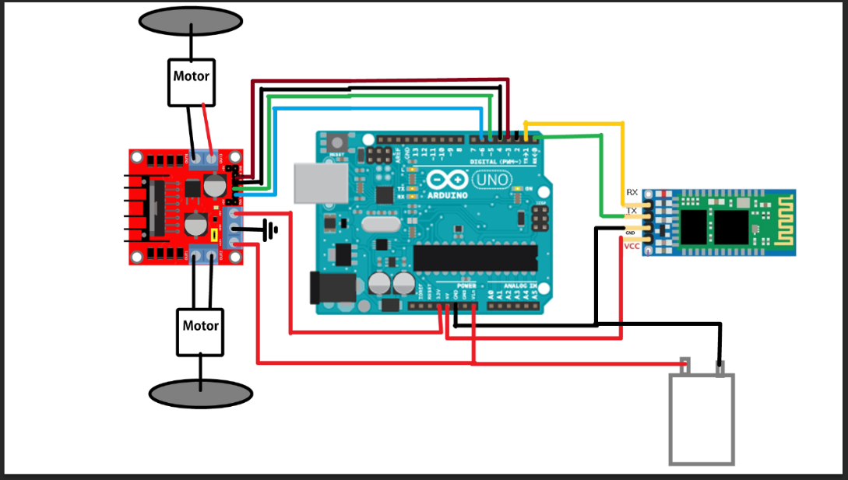

# Steps of Circuit Completion

* Make the body of pet by using wood pieces as shown in step1.
* Attach all the four motors with wheels.
* Then design the circuit by connecting Bluetooth module HC-05, Arduino UNO, L298N motor driver, 9 V cell and 12 V cell with the help of wires and jumper wires.
* Finally design the body which looks like a pet animal and then connect it with mobile phone for voice commands to run.

Step 1:

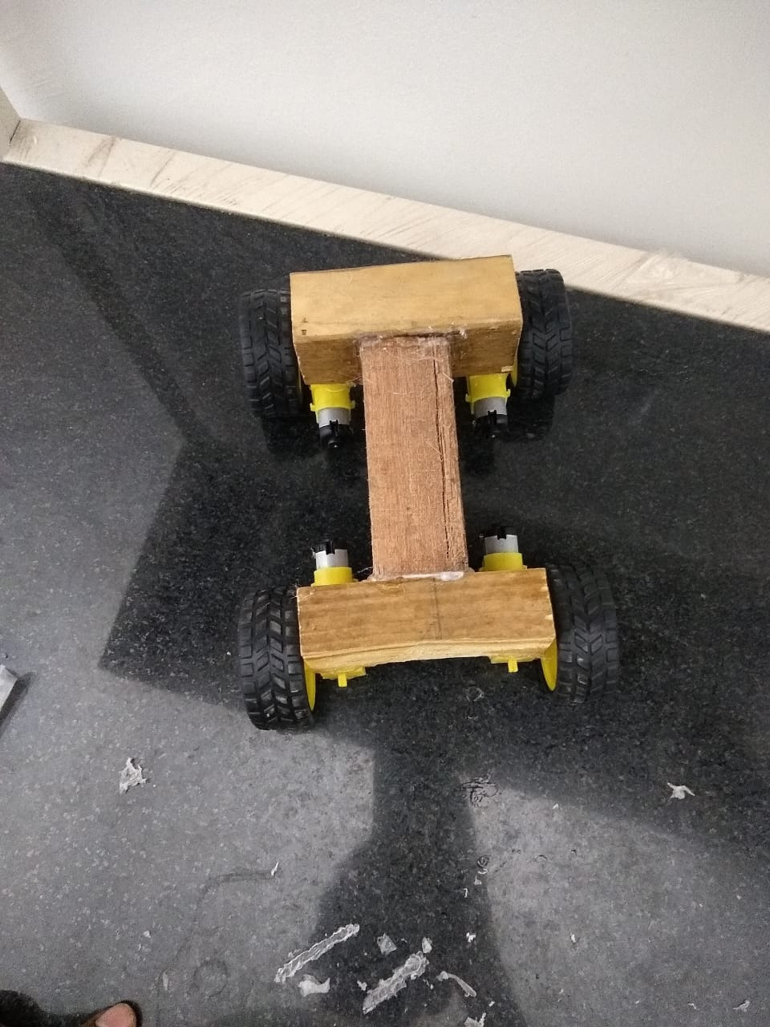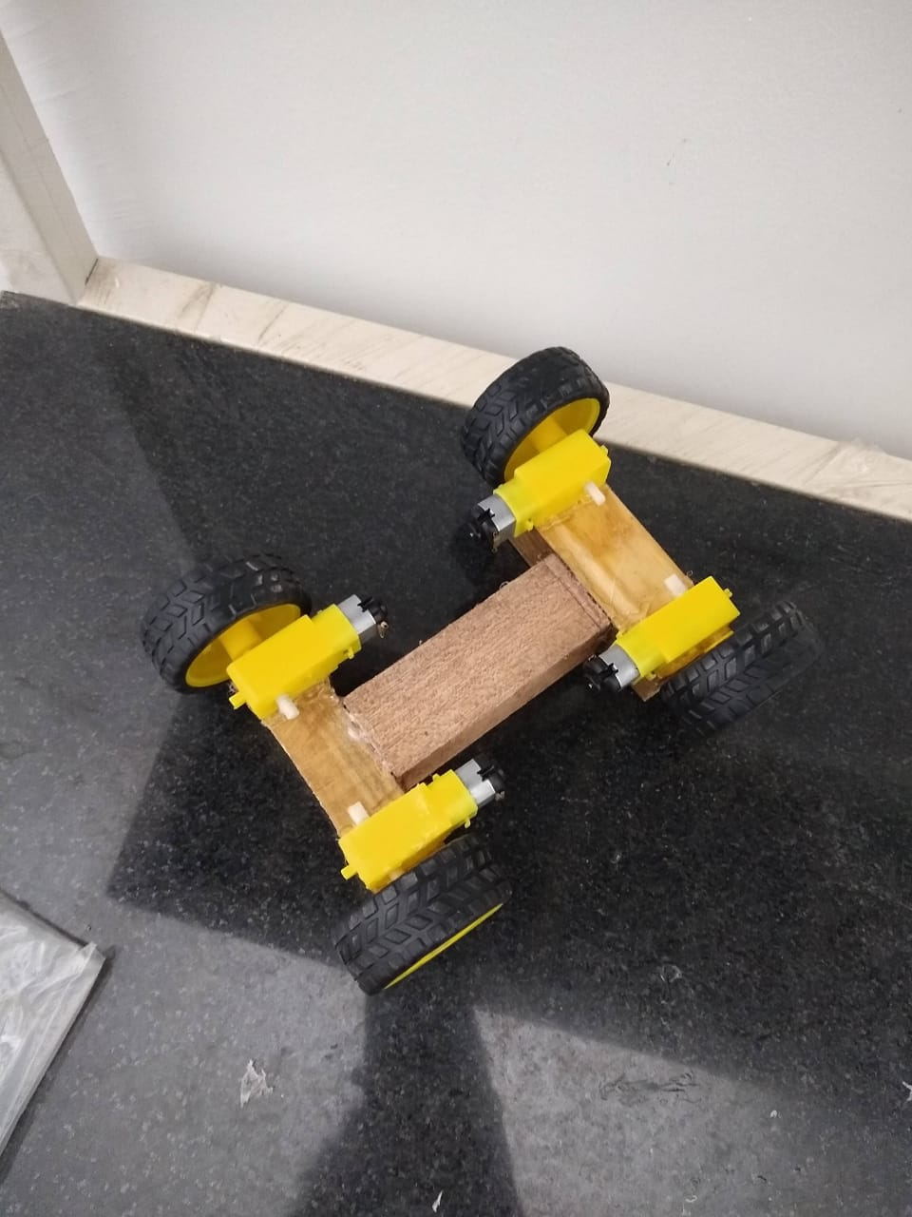

Step 2:

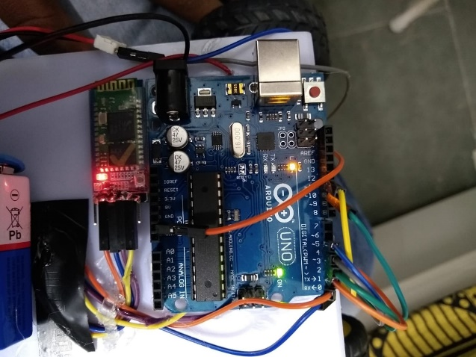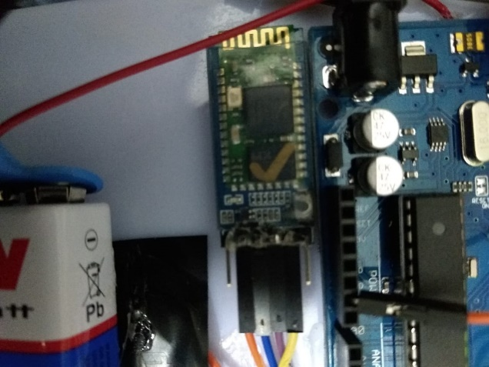

Step3:

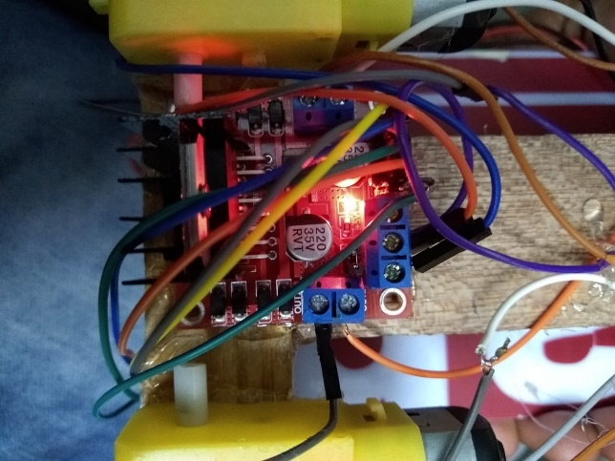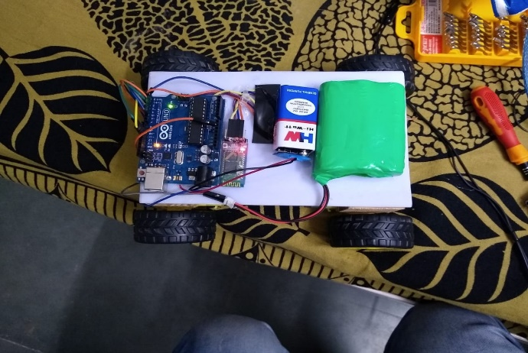

Step4:

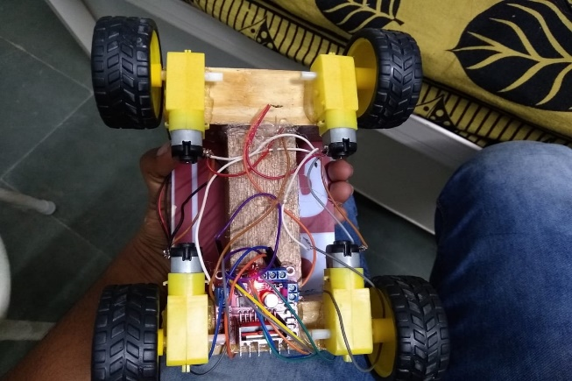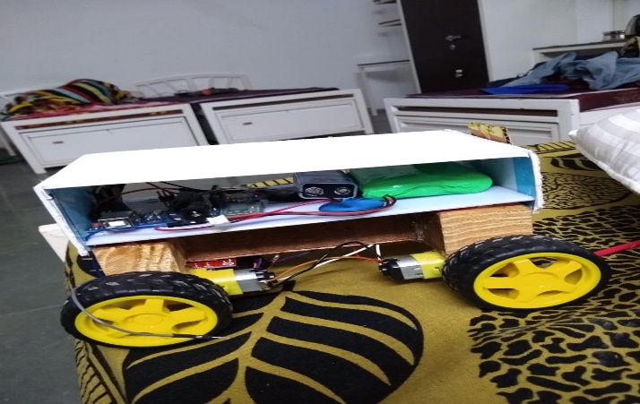

# Program Code

https://github.com/beeeproject-dsa/LAB